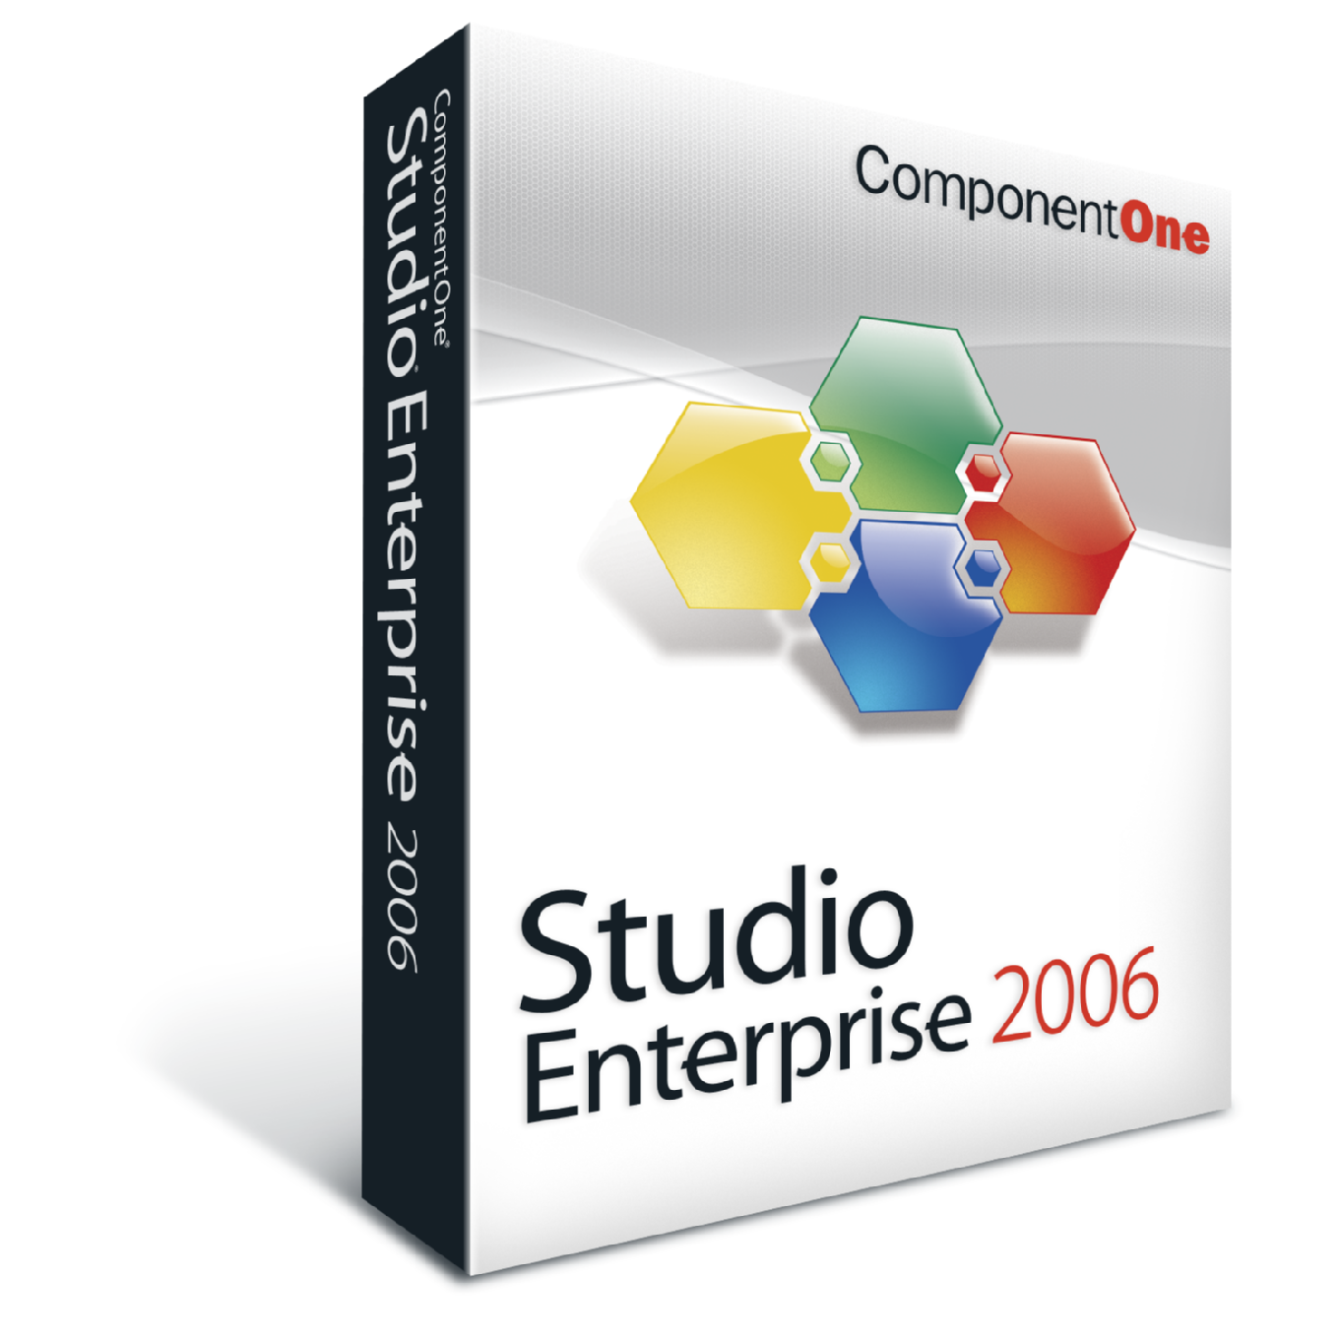

Studio Enterprise 2006 v2
DRAG, DROP, DEPLOY. It’s that easy.

The Largest and Most Complete Toolset
ComponentOne Studio Enterprise is the largest and most complete component toolset for developing all layers of Windows, Web and Mobile applications. Studio Enterprise accelerates visual development with drag and drop tools that simplify the design-time experience and extend the power of Visual Studio 2005. Now you can develop cutting-edge interfaces and add the most sophisticated feature sets to your Windows, Web, and Mobile applications with less code and in less time than ever before. Our latest release, Studio Enterprise 2006, adds an additional suite of 28 natively compiled products for Visual Studio 2005 to an already complete line of tools. This new suite of components delivers countless product enhancements focusing on simplifying the design-time experience, leveraging unique new features and extending the power of Microsoft Visual Studio 2005. Studio Enterprise provides components from four Studio subscriptions offering you over 180 remarkable components for .NET, ASP.NET, ActiveX, and Mobile Devices.
Discover the Power of Studio Enterprise .NET and ASP.NET 2.0 Components Without Having to Drop a Single Component on the Form. Studio Live is a sample framework with links to hundreds of samples of code, searchable product documentation, other technical resources:

http://www.componentone.com/LiveExamples.

Studio Enterprise Named "Best of Tech Ed"
We are pleased to announce that ComponentOne has been named "Best of Tech Ed" in the Software Components and Middleware category at the Windows IT Pro awards ceremony held recently at Tech Ed 2006 in Boston.
ComponentOne was also honored with 8 Visual Studio Magazine Reader's Choice awards also given during Tech Ed 2006. These awards, chosen by Visual Studio Magazine readers, recognize excellence in first-class development software in 22 categories. This marks ComponentOne's second consecutive year of winning the most awards of any vendor. Doc-To-Help, ComponentOne's single source Help authoring tool, also won an award for excellence in the Help authoring category.
New for 2006 v2

AJAX-Enabled Components Now Available
Build innovative, highly responsive Web interfaces with ease using the new AJAX-enabled WebGrid, WebReports, WebTreeView, WebTabStrip, and WebTopicBar Components.

New Studio Enterprise AJAX Feature Tour
Take a look at how you can add responsive UI elements to your Web applications with the new AJAX-enabled ASP.NET components.

New Productivity Technology
New visual design interfaces and framework that allows developers to set the components' most common properties without leaving the design surface. New SmartDesigners™ now available for C1FlexGrid, C1Preview and C1List components enhance the visual development experience.

New Charting Visual Effects
Add stunning new visual elements to your WinForm and WebForm charts including lighting effects, drop shadows and more.

New Studio Live Examples
Discover the power of the Studio Enterprise .NET and ASP.NET 2.0 toolset without having to drop a single component on a form! This application delivers live examples for .NET and ASP.NET 2.0 components, a sample framework with links to hundreds of samples and code, product documentation, links to ComponentOne HelpCentral online product resources and more.

508 Compliance
FlexGrid, TrueDBGrid, and List for .NET now fully support 508 compliance.

Plus: This release includes new features and enhancements to popular .NET tools including Reports for .NET, Sizer for .NET, PDF for .NET, XLS for .NET, Barcode for .NET, FlexGrid for .NET, Zip for .NET, and more.

  STUDIO ENTERPRISE INCLUDES
  .NET PRODUCTS | .NET 2.0 | .NET 1.x
  ADO.NET DataExtender
  FlexGrid for .NET
  True DBGrid for .NET
  Preview for .NET
  Reports for .NET
  Barcode for .NET
  Chart for .NET
  DataObjects for .NET
  Input for .NET
  List for .NET
  PDF for .NET
  XLS for .NET
  Zip for .NET
  Menus and Toolbars for .NET
  Spell for .NET
  Sizer for .NET
  ASP.NET PRODUCTS | .NET 2.0 | .NET 1.x
  WebGrid for ASP.NET
  WebReports for ASP.NET
  WebChart for ASP.NET
  WebDataObjects for ASP.NET
  WebMenus and WebBars for ASP.NET
  WebSpell IDE for ASP.NET
  PayPal eCommerce for ASP.NET
  PDF for .NET
  XLS for .NET
  Zip for .NET
  Flash for .NET
  MOBILE DEVICE PRODUCTS | .NET 2.0 | .NET 1.x
  Mask Edit for Mobile Devices
  FlexGrid for Mobile Devices
  Chart for Mobile Devices
  Zip for Mobile Devices
  ACTIVEX PRODUCTS
  True DBGrid Pro 8.0
  VSFlexGrid Pro 8.0
  VSVIEW 8.0 Classic Edition
  VSVIEW 8.0 Reporting
  Chart 8.0
  WebChart 8.0
  Query 8.0
  True DataControl 8.0
  True DBInput Pro 8.0
  True DBList Pro 8.0
  SizerOne 8.0
  VSSPELL 8.0



ComponentOne Doc-To-Help Enterprise 2006 v1
ComponentOne Doc-To-Help Word 2006 v1

The One-Click RoboHelp Replacement

Single Source Help Authoring for Word and HTML

Whether you are converting from RoboHelp or creating new projects, Doc-To-Help empowers authors to create HTML or Microsoft Word content and convert it to virtually every popular Help file format (including browser-based, platform independent Help) or printed documentation.
Doc-To-Help’s unmatched flexibility allows you to define Help elements, such as topic links, conditional text and glossary terms in the editor of your choice. Integrated toolbars and dialogs in Microsoft Word, FrontPage and Macromedia Dreamweaver allow you to visually create Help systems in the most powerful editors available while D2HML (Doc-To-Help Markup Language) allows you to use any editor you wish.

Feature Rich Help Authoring
Doc-To-Help is designed to give you every feature you need to create fully functional and customized Help files (in virtually any format) and printed manuals from a single source document, or set of documents. Use basic features, such as Topic Jumps and Pop-ups, or more advanced features like Conditional Text and Context Sensitive Help.

One-Click RoboHelp Conversion
Simply choose your RoboHelp HTML or Word project and click "convert". Doc-To-Help automatically converts the content, formatting and project settings into a build-ready Word or HTML source project.

New for 2006 v1

RoboHelp Converter Enhancements
We made our RoboHelp converters even more robust by adding more advanced RoboHelp project elements. With Doc-To-Help 2006v1, these RoboHelp project items will be converted:
- Conditional Build Expressions
- Single Source Layouts
NetHelp Project Merge
Many organizations have multiple projects from multiple authors that need merged into one. Doc-To-Help 2006 includes functionality that seamlessly merged multiple NetHelp files into one.
General NetHelp Enhancements
Doc-To-Help 2006 makes a few important enhancements to NetHelp such as a menu for multiple links and a noise list for NetHelp search.
Live Links in Manual
Doc-To-Help 2006 gives you the option of creating live links for your printed manual output.
Documenter for .NET Enhancements
Doc-To-Help 2006 includes two enhancements for Documenter for .NET:
- Links for Standard Framework Types in Help 2.0
- Support for Non-Standard XML Comment Tags (Supported by nDoc)
We are pleased to announce that ComponentOne has been named "Best of Tech Ed" in the Software Components and Middleware category at the Windows IT Pro awards ceremony held recently at Tech Ed 2006 in Boston.
Doc-To-Help, ComponentOne's single source Help authoring tool, also won an award for excellence in the Help authoring category.

